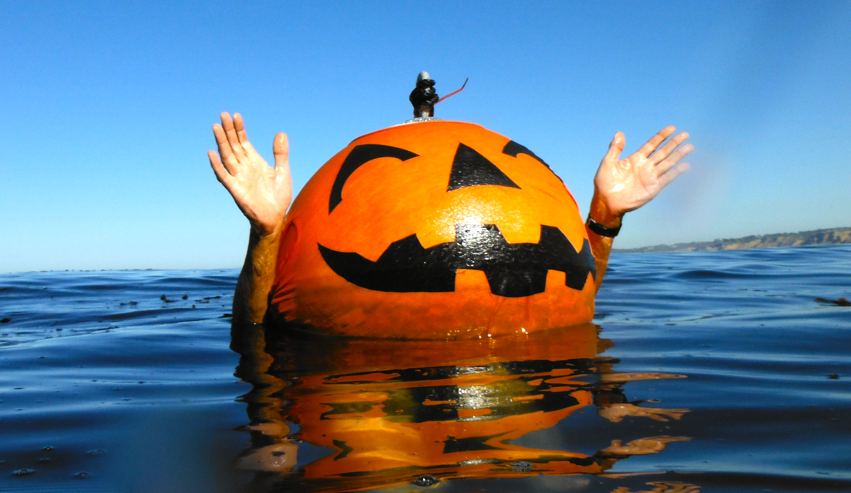
La Jolla Cove Swim Club’s
Halloween Spookfest
SUNDAY, October 27, 2019

On SUNDAY October 27, starting at about 8:30 AM, we’ll have a social event at the cove.
The Club will provide Starbucks coffee and Costco muffins.
Please bring some Halloween goodies to share homemade if you are so inclined…. or purchased.

“Decorate Your Swim Cap” for Halloween.
Make a swim cap of some sort and wear it.
Be creative; this can either be a cap that can actually be worn for swimming or a cap that needs to stay dry.

Feel free to show up in a full costume.

Halloween and/or aquatic themes are suggested.

Will we see decorations on the ¼ mile BOO-ey?

